**Project Design Phase-II**

**Data Flow Diagram & User Stories**

|  |  |
| --- | --- |
| Date | 03 October 2022 |
| Team ID | PNT2022TMID48096 |
| Project Name | Project – Signs with smart connectivity for better road safety |
| Maximum Marks | 4 Marks |

**Data Flow Diagrams:**

A Data Flow Diagram (DFD) is a traditional visual representation of the information flows within a system. A neat and clear DFD can depict the right amount of the system requirement graphically. It shows how data enters and leaves the system, what changes the information, and where data is stored.

**DFD**

**Example:** [**(Simplified)**](https://developer.ibm.com/patterns/visualize-unstructured-text/)

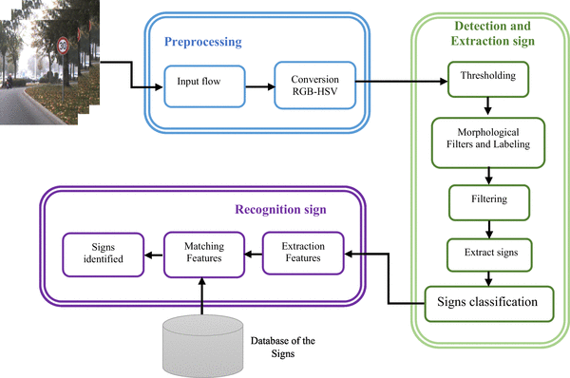

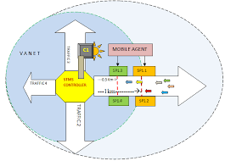

**User Stories**

Use the below template to list all the user stories for the product.

| **User Type** | **Functional Requirement (Epic)** | **User Story Number** | **User Story / Task** | **Acceptance criteria** | **Priority** | **Release** |
| --- | --- | --- | --- | --- | --- | --- |
| Customer (Mobile user) | Registration | USN-1 | As a user, I can register for the application by entering my email, password, and confirming my password. | I can access my account / dashboard | High | Sprint-1 |
|  |  | USN-2 | As a user, I will receive confirmation email once I have registered for the application | I can receive confirmation email & click confirm | High | Sprint-1 |
|  |  | USN-3 | As a user, I can register for the application through Facebook | I can register & access the dashboard with Facebook Login | Low | Sprint-2 |
|  |  | USN-4 | As a user, I can register for the application through Gmail |  | Medium | Sprint-1 |
|  | Login | USN-5 | As a user, I can log into the application by entering email & password |  | High | Sprint-1 |
|  | Dashboard |  | We can take templates and session of previous classes | I can access my dashboard | High | Sprint-1 |
| Customer (Web user) | Organising skill | USN-1 | By browsing about our title we become a good trainer in web using | I can access my account | Medium | Sprint-2 |
| Customer Care Executive | Task | USN-2 | It is professional responsible for communicating the how’s and why’s regarding service expectations within a company | We can get the ability to lead a team | High | Sprint-1 |
| Administrator | Responsibilities | USN-3 | Administrator supports the smooth running of customer service by carrying out clerical task & projects. | As a administrator we develop the agile development project | High | Sprint-1 |